

Why Us?

Santi’s Soccer Store offers the cleats of the highest quality at an affordable price. We are the number one option for all Canadian soccer players.

What is it?

Santi’s Soccer Store is quite simply, an Online Soccer Store that sells cleats. It is an easy to use program that allows customers to browse and purchase soccer cleats.

**Santi’s Soccer Store**

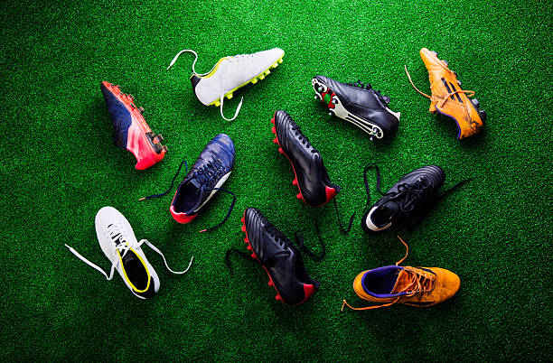

Who is it for?

The Soccer Store is made for any soccer player who is interested in buying the best cleats at affordable prices. Although the cleats are designed for competitive athletes, the website is easy to use for people of all ages and experience.



Innovative New Code/Concepts Used

Santi’s Soccer Store uses a wide variety of new code/concepts that add to the user experience and make it run more efficiently:

* ScrollPane: A JScrollPane was used to allow the customer to scroll down the lists of cleats, making it much better looking and easier to browse
* Multiple Windows: multiples windows were used in order to make the code easier to organize, and to allow the user to go through different types of pages with ease
* JMenu: A JMenuBAr, a JMenu, and JMenuItems were used to allow the user to navigate back to previous webpages
* requestFocus(): This was used to move the text cursor for the TextFields
* Custom Colours: I was able to add custom colours to make the website and the cleats more appealing to the customer
* Extended Frame: I was able to make the size of the frame change to fit the size of the screen, instead of making it a set size for all screens

How does it work?

Using our website is fast and easy, all you need is JGrasp and all of the files that come in the ISU AGU folder.

You start the website by compiling and running the Store.java file. After that, you just navigate the website by using JButtons, JComboBoxes, JTextfields, and the menu at the top of the pages.

Buttons are used by clicking with the mouse. Combo Boxes are used by selecting from the dropdown list. Text fields are used by typing information and pressing enter.

**Santi’s Soccer Store**